Francotyp-Postalia - ‘Mymail’: FM2504000 to 2504999

This is a continuation of the FM2503 series and started in January 2007.

The FM series is uncommon and scans of other examples would be appreciated.

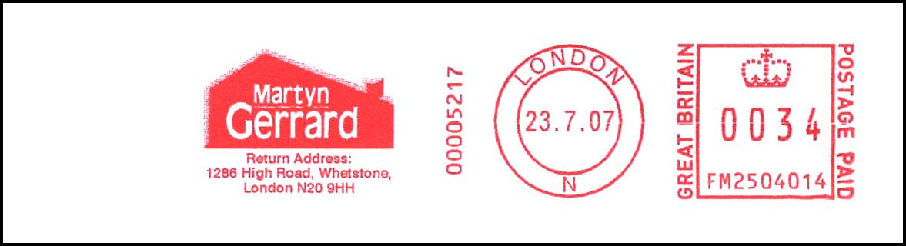
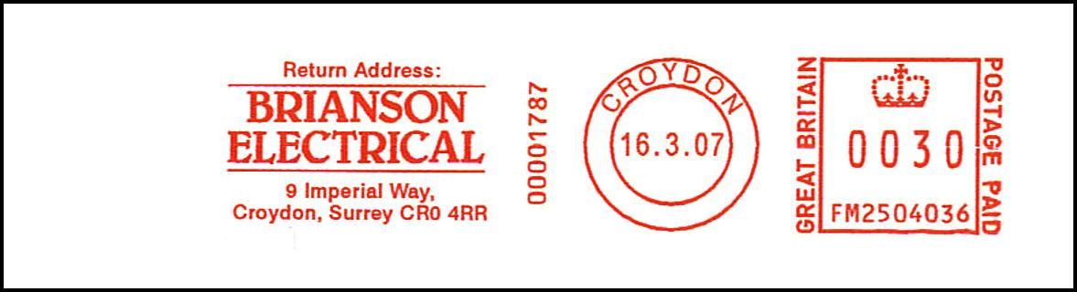
FM2504036
CROYDON
E16.03.07
User: Brianson Electrical
Thematics: None
Notes: None
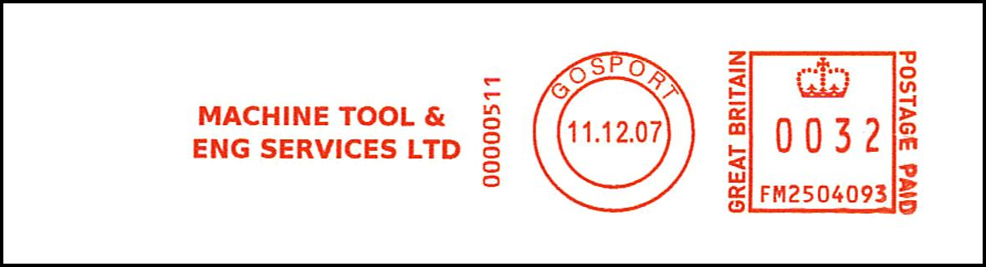
FM2504093
GOSPORT
E11.12.07
User: Machine Tool & Engineering Services Ltd
Thematics: None
Notes: None
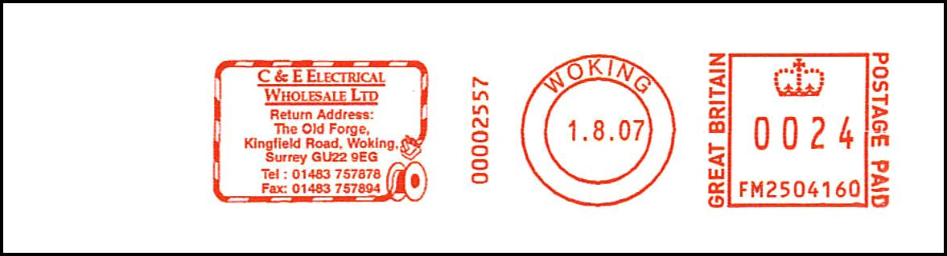
FM2504160
WOKING
E26.04.07, L01.08.07
User: C & E Electrical Wholesale Ltd.
Thematics: None
Notes: None
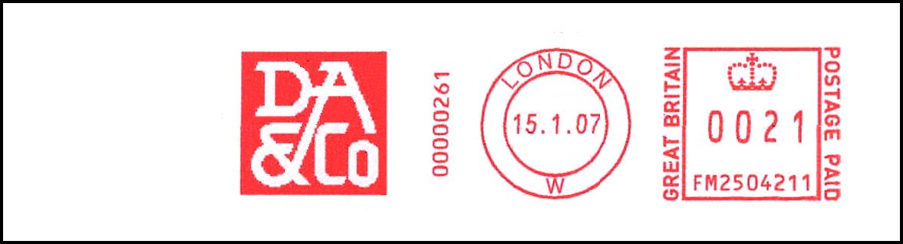

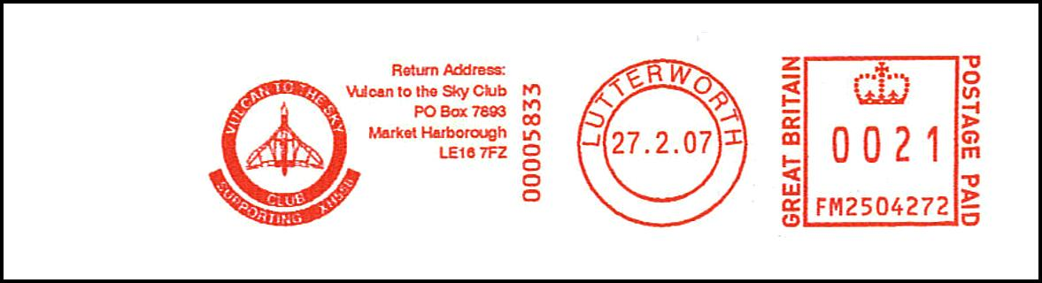
FM2504272
LUTTERWORTH
E27.02.07
User: Vulcan to the Sky Club
Thematics: Aviation
Notes: None


FM2504369
READING
E12.03.07
User: Unknown
Thematics: None
Notes: None
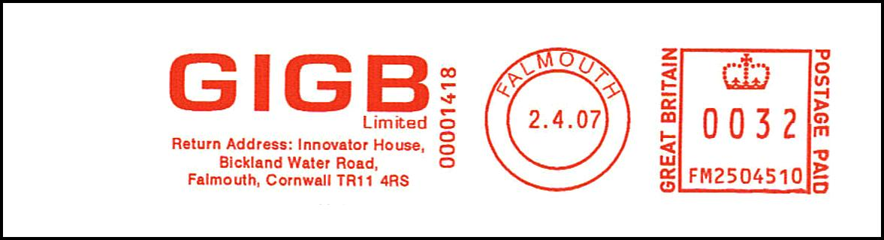
FM2504510
FALMOUTH
E02.04.07
User: GIGB Ltd.
Thematics: None
Notes: None
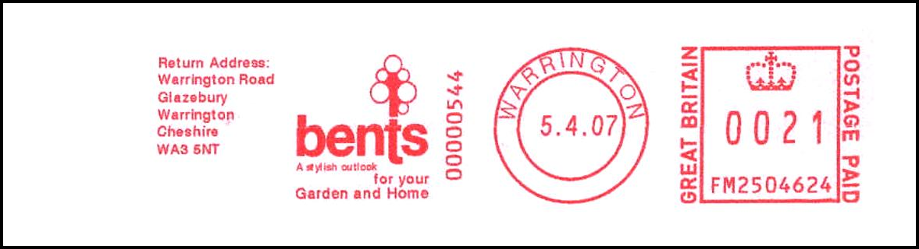
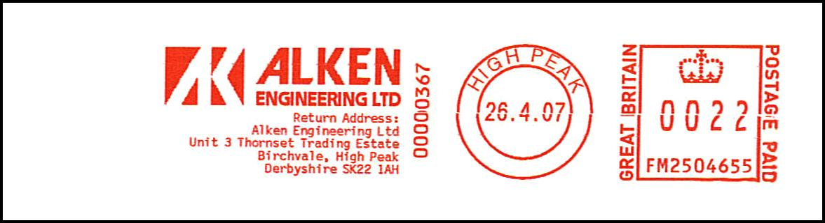
FM2504655
HIGH PEAK
E26.04.07
User: Alken Engineering
Thematics: None
Notes: None
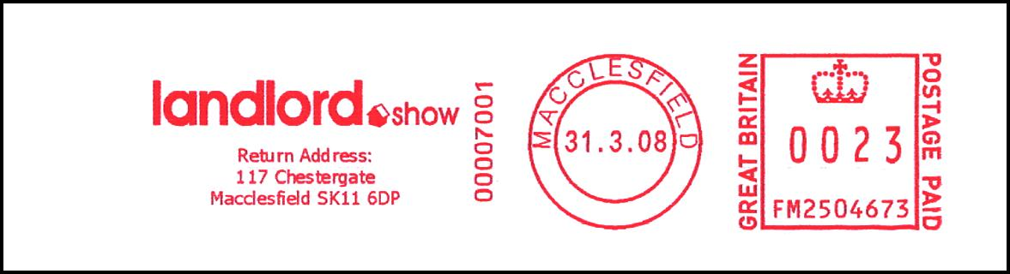
PM 06.04.08

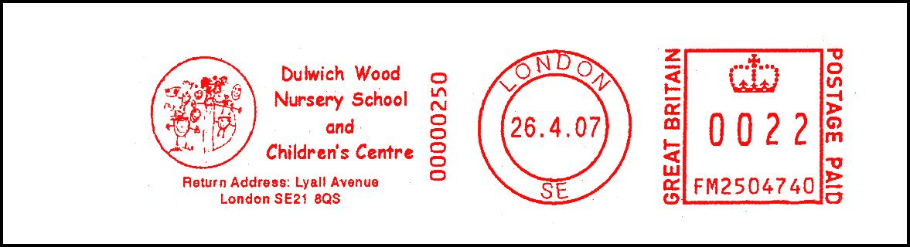
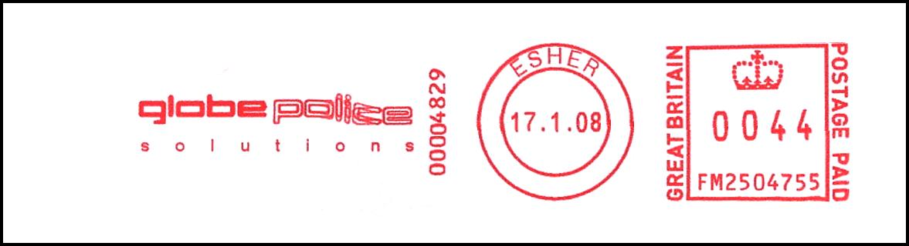
FM2504785
27.04.07
No other details available

